2016 50-Year Members
Karen Carter
“I joined the Seattle Shores Chorus in 1966, then shortly after transferred to Lakeside. I was with Lakeside until Zoe retired; I think it was 1998. I then joined Pacific Sound Chorus, where I am still a member. I also dual with Voices Northwest Chorus.
I’ve been in 15 (or maybe more) quartets and I’ve got 13 quartet medals! My quartet, Simpatico, won regional in 1997. The members of that quartet were Katy Hawley, Sidney Thompson, Melanie Wroe and myself. I have more chorus medals than I can count, all earned with Lakeside, Pacific Sound and Voices Northwest.
Sweet Adelines has been my life, my family, and my hobby. I’ve loved every minute of being a Sweet Adeline. I wouldn’t have had I any other way.”

Elsie Jussel
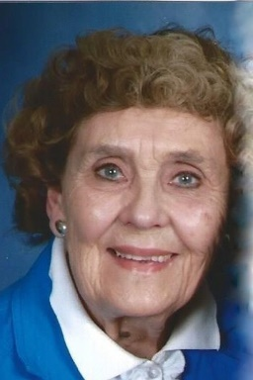
“Fifty years...time flies when you are having fun! One of the best decisions I ever made was to attend a Sweet Adeline Chorus rehearsal in 1966. Not only has that resulted in 50 years of singing, but also 50 years of developing many lasting friendships.
I joined the Bellingham Chapter and was with them for 33 years. When they disbanded in 1997, I went 30 miles south to join the Sea Island Sound Chapter (now Harmony Northwest), and I continue to sing with them.
During those years I have held many offices and served on many committees. I edited a monthly member newsletter for a number of years, and served as backstage RN during quartet contests.
I’ve seen many changes in the organization regarding hair styles, costumes, music and choreography, and have gone through great quantities of glitter and sequins! Being a member has helped me watch my weight, too, as I don’t want to ask the costume committee for a larger costume!
A very touching and special honor for me was being chosen by my chorus members as Most Inspirational Member three times over the 50 years!”

Ruth Ramey
“I was introduced to Sweet Adelines by my husband, Al, who sang in a local men’s chorus. In 1966 I joined the Puget Sound Chapter and sang lead. I also served on the Board as president and treasurer over the years. I am currently a retired banker, enjoy traveling, antiques, and rescuing animals. My husband and I currently have six puppies and two cats!”

Continued on next page
Marilyn Rogers
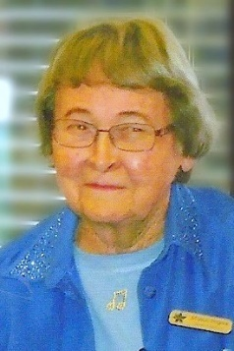
“In the mid-60s a friend took me to see a Lakeside Chorus show and I decided when I moved to where a chorus was located, I'd join, which happened in 1966 when I moved to Renton and attended my first rehearsal with the Renton Chorus. So determined was I to join that I pulled out my checkbook upon arrival, to which the treasurer informed me, tactfully, that first I had to come to four rehearsals! During the next 41 years I served in all of the chorus’ offices and chaired many committees.
The Renton Chapter moved its rehearsals to Kent, and became Jet Cities Chorus, where I remained until I retired from the chorus in 2008 and became a Chapter-at-Large member. This really is a lifetime hobby, though, because I continue to enjoy watching Sweet Adelines performances, especially Jet Cities' Sweetie Pie Socials.
I became involved with regional duties when I assisted with the ditto machine production (we later changed to mimeograph) of Region 13’s Clover Leaf monthly newsletter. The machine was set up in my basement in Renton, and we assembled copies on the ping-pong table.
Patty Warren was Regent and Nominated me for the Region 13 Board of Directors, my work as Regional Historian began while I was a Board member, and I enjoyed that for a few years, taking pictures at regional events and making scrapbooks during the 1980s. Serving on the Board is a wonderful way of making lasting friendships with great people!
Now living at Merrill Gardens at Renton Centre, I became active in residential government soon after moving in. I enjoy Wii Bowling competition against other Merrill Gardens facilities, bell choir, and playing tile and card games.

Sandy Shaw
“In May of 1966 I walked into a Lakeside rehearsal, auditioned, and was put in the lead section. One week later I joined a quartet as tenor, and in September we were on the chapter show. I was hooked for life!
I was lucky enough to sing with the Lakeside Continentals, and we won regional in 1970. Thus began the most fun of my life and we competed in five International contests! In the meantime, Lakeside was the first competitor in the first ever Sweet Adelines International chorus contest. Over the years we maintained a high degree of excellence and my cache of chorus medals grew. I was a part of two wonderful tours: one to Australia and the other to Germany and Austria.
In 1990 I moved over to Pacific Sound Chorus, and I also sang in Ovation (the Region 13 Chorus of Quartet Champions). However, some years later, a medical problem arose and I could no longer stand on the risers, at which time I transferred to Chapter-at-Large. I feel very blessed to have had these many years with Sweet Adelines.”

Continued on next page
Joyce White
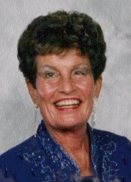
Joyce joined Region 24’s St. Helen's chorus when her daughter was only 1 year old. She directed Region 24’s Newberg, West Hills, and St. Helens Choruses--all at the same time!--while she also directing her church choir. Joyce then joined Blue Lake Chorus, where she was part of the music leadership and helped with the merger and transition of the Blue Lake and Willamette Sound Choruses Pride of Portland. In addition, Joyce was a sought-after coach for both choruses and quartets throughout the Region.
Joyce's resonant sound made her a “go to” quartet bass, and won Regional Quartet Championships five times with her quartets: Carousel (1985), Renaissance (1987), Surround Sound (1992, 1993), and Final Touch (2003). She was solid member of Region 24’s Gold Country before it merged into Ovation, and you could always count on her to help.
Additionally, Joyce was an English and music teacher for many years-- for middle schoolers--for 25 years. She loves warm weather and has done much travelling through the world.
Although Joyce is now a member of Chapter-at-Large, she continues to share her music knowledge and experience by giving personal vocal lessons.

