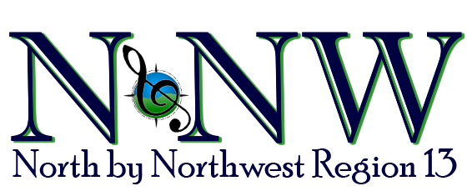

HEART OF THE NORTHWEST AWARD CRITERIA
The Heart of the Northwest is an award presented each year by the Regional Management Team to a Region 13 member who displays enthusiasm, commitment and exemplifies all that is a Sweet Adeline.

Chapters may nominate members for this award. The deadline for receiving nominations is February 5, 2024. Nomination forms are available on the website. The final decision will be made by the Membership Coordinator, along with the last four winners of the award, based on a review of the nominated candidates. This will be completed prior to contest and the award will be presented during competition weekend. All candidates, along with the award recipient, will be posted on the regional website after contest.

Is there someone in your chapter you would like to nominate for this award who meets the criteria listed below? Please send in the Heart of the Northwest Nomination Form along with a bio and picture (which will be framed and put on display at contest). Each candidate will be recognized and presented with her picture and bio at the Kickoff when the award winner is announced.

Criteria includes a member who...
- Exemplifies all that is a Sweet Adeline
- Believes in the importance of her personal marketing responsibility to present her chorus, the region, and SAI in the best positive way to the general public
- Serves her chorus and the region to the best of her ability for the love of the organization
- Shows keen interest in Sweet Adelines and actively participates in both her chorus and regional activities and functions
- Generously donates her time and skills to her chorus and the region
- Is a great ambassador for Sweet Adelines and has a positive influence on her chorus and the organization
- Displays enthusiasm and commitment to promoting the Harmonize the World theme of SAI and Region 13 through her music and interpersonal skills
- Willingly shares skills and knowledge with other members
- Willingly works without expectations of recognition

Updated 6/26/2023

