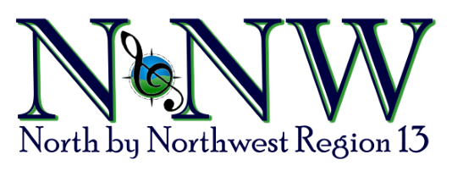

HEART OF NORTHWEST AWARD CRITERIA
Is there someone in your chorus you would like to nominate for this award who meets the criteria listed below? Please send in the Heart of the Northwest Nomination Form along with a bio and picture which will be framed and put on display at contest. Each candidate will be recognized and given her picture and bio at the contest Kickoff when the winner of the award will be announced.
The previous recipients along with the Region 13 Membership Director will make the final decision based on a review of the candidates submitted. This will be done in January so the award can be given at contest. All candidates, along with the award recipient, will be posted on the regional website after contest.

Criteria includes a member who...
- Exemplifies all that is a Sweet Adeline
- Believes in the importance of her personal marketing responsibility to present her chorus, the region, and SAI in the best positive way to the general public
- Serves her chorus and the region to the best of her ability for the love of the organization
- Shows keen interest in Sweet Adelines and actively participates in both her chorus and regional activities and functions
- Generously donates her time and skills to her chorus and the region
- Is a great ambassador for Sweet Adelines and has a positive influence on her chorus and the organization
- Displays enthusiasm and commitment to promoting the Harmonize the World theme of SAI and Region 13 through her music and interpersonal skills
- Willingly shares skills and knowledge with other members
- Willing works without expectations of recognition

HEART OF THE NORTHWEST AWARD
NOMINATION FORM

NAME:
ADDRESS:
EMAIL: TOTAL YEARS A MEMBER: __________
CHORUS AFFILIATION(S):
LIST CHORUS ACTIVITIES:

LIST REGIONAL ACTIVITIES:

LIST INTERNATIONAL ACTIVITIES:

COMMENTS ON NOMINEE’S QUALIFICATIONS:

(If more space is needed, please add an additional sheet.)

Submit this nomination with a 3 X 4 color photo of your nominee by December 31, 2018 to:
Sharon Stockstad / 31 Southview Road / Clancy, Montana 59634
Phone: 406-442-6825 / Email: sasngjs@msn.com

Submitted by: ______________________________________________ Chorus:
Phone: ________________________________________ Email:
6/2018

