A Cappella Express!!!
Festival Workshop Fundraiser Registration Form

Date: Saturday, February 18, 2023
Ages: 10-25 years; Male/Female/They
Times: 9:00am-4:30 pm rehearsals
6:00pm Dress rehearsal on stage
7:00pm-9:00pm performances
Location: Century High School,
2800 SE Century Blvd. in Hillsboro, Oregon 97135

With Valkyries Quartet, the 2022 Rising Star Champions!
Sponsored by SAI North by Northwest Region 13

-------------------------- Please cut here and return form to Marsha Kelly at YouthEducOutreach@sairegion13.org -----------------------
Sign-up form - please fill out completely

Student’s name:______________________________________ Age:_____ School attending:___________________________________

Contact email address:________________________________ Contact phone: ______________________ Shirt size: ___________

Singing experience: _____ school choir member _____ other music festivals _____ private voice student

_____ other vocal experience

Voice part preferred: _____ Soprano / Lead/Melody _____ Soprano / Tenor / Harmony part

_____ Alto I / baritone Harmony part _____ Alto II / Bass Harmony part

Fee: $30 per student - includes festival participation, t-shirt for performance, concert admission

Payment: hsdwebstore.graystep.com/(S(f3jyncaky5lvrkpgbu2ht3na))/apps/main/Index.aspx?orgID=70949#/1/product/240
Questions? Please email: YouthEducOutreach@sairegion13.org

I agree to: - Bring my own sack lunch to be eaten at Century High School
- Practice my songs with provided learning tracks and sheet music prior to the festival date
- Wear the designated festival shirt with black pants/skirt/shoes/socks for the performance
- Return to Century High School at 6:00 pm for the dress rehearsal and following performance
- Remain in the audience to watch the second half of the performances

Signature (parent/guardian)_____________________________________________________________________

Please print name of parent/guardian_____________________________________________________________
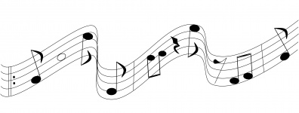
Come and join the fun!!!

